Unit 1 Introduction To Computers

A computer is a device that can be instructed to carry out sequences of operations automatically via computer programming. In this unit student will get familiarize with a computer. They will learn about the advantages of using a computer and the concept of data and information. They will also learn about input, processing, output and storage operations.

**Learning Objectives**

After completing this unit, students will be able to:

* Define computer
* Define types of computer
* Define data and information
* Explain the advantages of using computers
* Define hardware and software
* Know the difference between hardware and software
* Know input devices
* Know system unit
* Know storage devices
* Know output devices
* Know communication devices
* Know how a computer works
* Describe four basic operations performed by a computer

# What is a Computer?

A **computer** is an electronic device that manipulates information, or data. It has the ability to **store**, **retrieve**, and **process** data. You can use a computer to **type documents**, **send email**, **play games**, and **browse the Web**. You can also use it to edit or create spreadsheets, presentations and even videos.

When most people hear the word computer, they think of a personal computer such as a desktop or laptop. However, computers come in many shapes and sizes, and they perform many different functions in our daily lives.

DO YOU KNOW?

**Charles Babbage** is called the "Father" of the computer. The First mechanical computer designed by Charles Babbage was called [Analytical Engine](http://ecomputernotes.com/fundamental/introduction-to-computer/analytical-engine)**.**It uses read-only memory in the form of punch cards.



.

# Types of Computers

* **Desktop Computers**

Many people use **desktop computers** at work, home, and school. Desktop computers are designed to be placed on a desk, and they're typically made up of a few different parts, including the computer case, monitor, keyboard, and mouse.

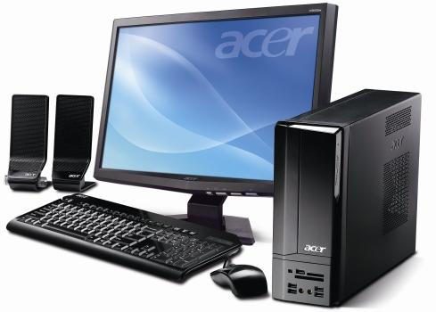

Figure 1.1.1 (a) Desktop PC

* **Laptop Computers**

**Laptops** are battery-powered computers that are more portable than desktops, allowing you to use them almost anywhere.

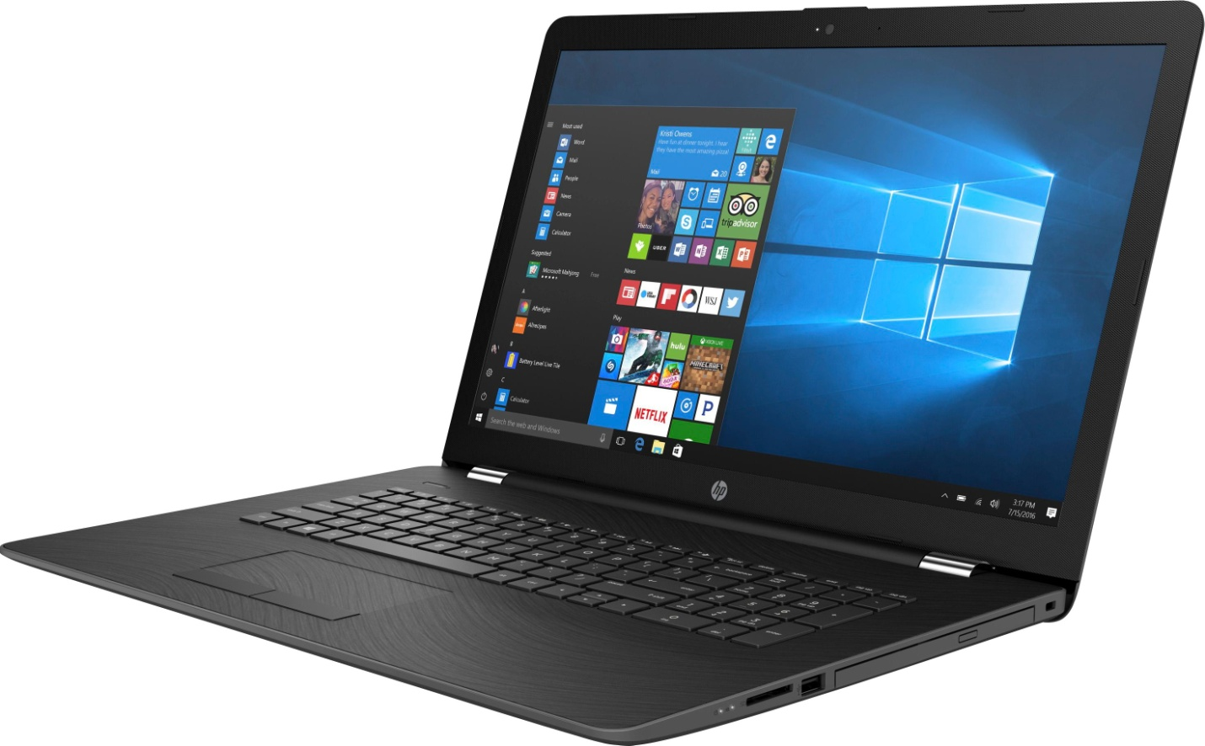

Figure 1.2.1 (b) Laptop

* **Tablet Computers**

**Tablets** are handheld computers that are even more portable than laptops. Instead of a keyboard and mouse, tablets use a touch-sensitive screen for typing and navigation. The iPad is an example of a tablet.

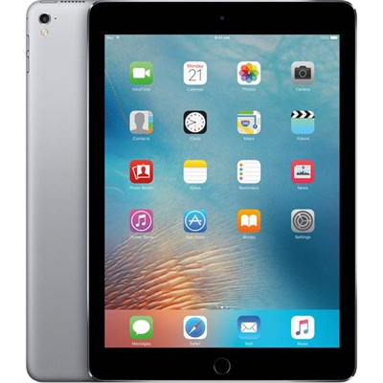

Figure 1.3.1 (c) Tablet

* **Servers**

A **server** is a computer that serves up information to other computers on a network. For example, whenever you use the Internet, you're looking at something that is stored on a server. Many businesses also use local file servers to store and share files internally.

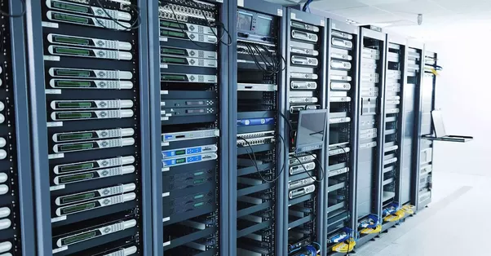

Figure 1.4.1 (d) Server

Smartphones, wearables and game consoles are also examples of a computer.

# Data and Information

**Data** are plain facts. The word data is plural for datum. Data is the raw material that can be processed by any computing machine. Data can be represented in the form of numbers and words which can be stored in [computer](http://ecomputernotes.com/fundamental/introduction-to-computer/what-is-computer)'s language.

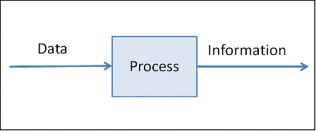

Figure 1.1.2 (a) Data processing

When data are processed, organized, structured or presented in a given context so as to make them useful, they are called **Information**. It is not enough to have data. Data themselves are fairly useless, but when these data are interpreted and processed to determine its true meaning, they becomes useful and can be named as Information. Information should have following important traits:

* **Timely** − Information should be available when required.
* **Accuracy** − Information should be accurate.
* **Completeness** − Information should be complete.

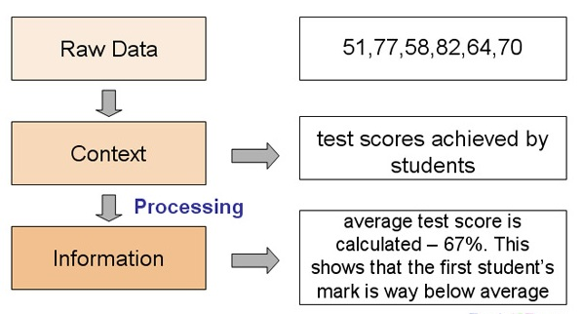Figure 1.2.2 (b) Example of Data processing

DO YOU KNOW?

The collection and manipulation of items of data to produce meaningful information is called **data processing**. 

.

# Advantages of Using Computers

There are several advantages and benefits of using computers. Some of them are listed below:

* **Speed**

Computer is a very fast device. It is capable of performing calculation of very large amount of data. It can perform billions of calculations in a few seconds as compared to man who will spend many months for doing the same task.

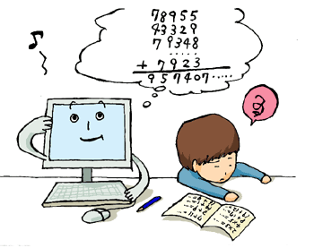

Figure 1.1.3 (a) Speed

* **Accuracy**

In addition to being very fast, computers are very accurate. The calculations are 100% error free. Computers perform all jobs with 100% accuracy provided that correct input has been given.

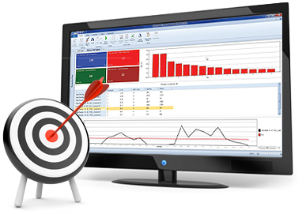

Figure 1.2.3 (b) Accuracy

* **Storage**

Memory is a very important characteristic of computers. A computer has much more storage capacity than human beings. It can store large amount of data. It can store any type of data such as images, videos, text, audio and many others.

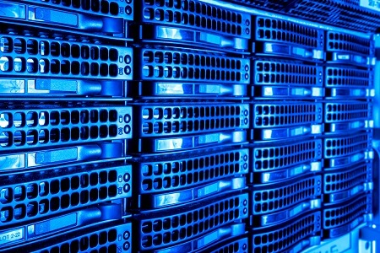

Figure 1.3.3 (c) Storage

* **Reliability**

A computer is a reliable machine. Modern electronic components have long lives and they are designed to make maintenance easy.



Figure 1.4.3 (d) Reliability

* **Automation**

Computer is an automatic machine. **Automation** means ability to perform the given task automatically. Once a program is given to computer i.e. stored in computer memory, the program and its instructions can control the program execution without human interaction.

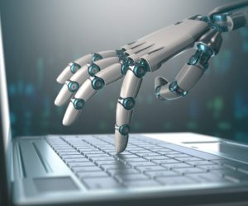

Figure 1.5.3 (e) Automation

* **Online Shopping**

People tend to use computer and internet while purchasing and selling their goods. This has increased the market reach for sellers and this has only been possible due to computers.



Figure 1.6.3 (f) Online shopping

* **Online Education**

Computer is a box full of knowledge. Many online websites offer courses on a wide variety of subjects which students can take while sitting at home. All lectures and needed materials are provided via online platforms, so students can easily access them from the comfort of their home.



Figure 1.7.3 (g) Online education

* **Forecasting Weather and Earthquakes**

Super computers are used in weather forecasting, predicting earthquakes and volcanic eruptions. The scientists can predict the time and hence they can save people from these natural disasters.

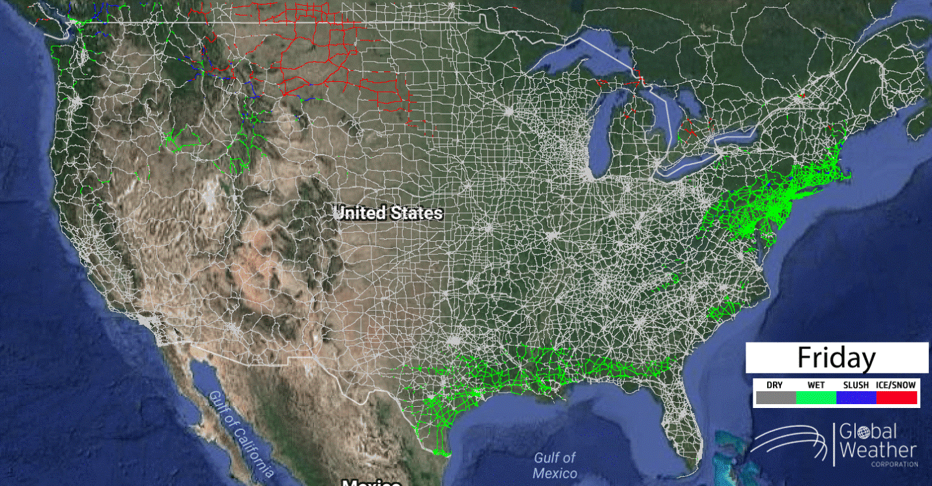

Figure 1.8.3 (h) Weather forecast

# The Components of a Computer

A computer has different components to perform a variety of tasks. These components can be divided into two main types:

* **Hardware**

**Hardware** is any part of computer that has a physical structure like keyboard or mouse. It includes all those parts that we can see and touch like input unit, output unit and system unit.

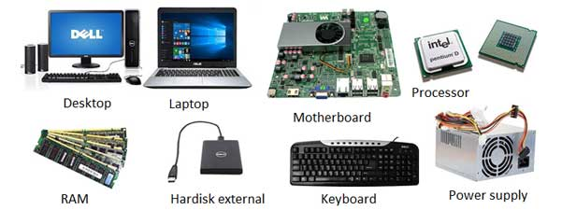

Figure 1.2 (a) Hardware components

* **Software**

**Software** is any set of instructions that tells the hardware what to do and how to do it. Examples of software include web browsers, games, and word processors. Below, you can see an image of Microsoft PowerPoint, which is used to create presentations.

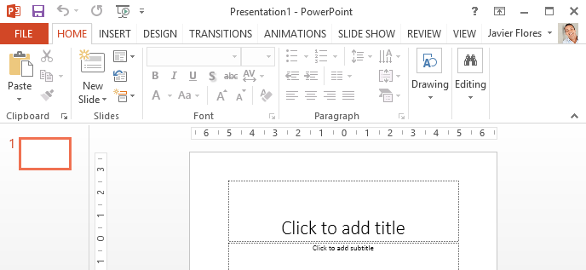

Figure 1.2 (b) PowerPoint software

# Difference Between Hardware and Software

|  |  |
| --- | --- |
| **Hardware** | **Software** |
| 1. Physical parts of a computer are known as hardware. | 1. A set of instructions given to the computer are known as software. |
| 1. You can touch and feel hardware. | 1. You cannot touch and feel software. |
| 1. Hardware is constructed using physical material or components. | 1. Software is developed by writing instructions in programming language. |
| 1. Hardware is repaired in case of problem. | 1. Software is debugged in case of problem. |
| 1. Examples of hardware include monitor, keyboard, mouse, printer, system unit, motherboard etc. | 1. Examples of software are Microsoft Windows, MS word, MS powerpoint, media player, Internet Explorer etc. |

# Input Devices

Devices that are used to input data into computer are called **input devices.** Some of the most widely used input devices are keyboard, mouse, microphone, scanner and digital camera.

* **Keyboard**

Keyboard is the most commonly used input device. It allows a user to enter alphabets, numbers or symbols into the computer. It has small button called **keys.** The keys are laid out in QWERTY pattern.

DO YOU KNOW?

If you look at the top left corner of the *alphanumeric* keypad, you can see the letters Q W E R T Y placed together. 

.

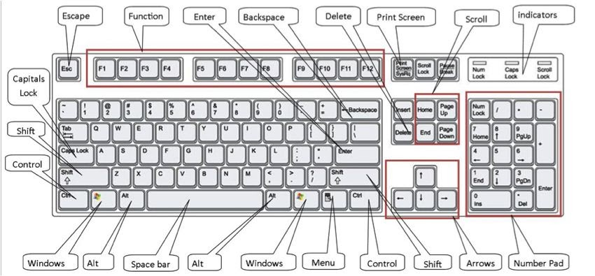

Figure 1.2.2 (a) Keyboard

A typical keyboard can be classified into following sections

* + **Function Keys**

**Function keys** are located at the top of the keyboard. The purpose of these keys is based on the software we are using. For example pressing the F1 key in Windows opens up the Help window.

* + **Alphanumeric Keys**

The collection of letters, numbers and punctuation keys along with some special keys like Tab, Caps Lock, Backspace, Enter, Shift, Ctrl and Alt is known as **Alphanumeric keys.**

* + **Number Pad/ Numeric Keys**

The number pad or numeric keys are located at the right side of a standard keyboard. This section contains digit keys and mathematical operator keys (+,-,*,/)

* + **Cursor Control / Navigation Keys**

The arrow keys and the scroll keys are together known as **navigation keys** or **cursor control keys.** These keys are used to move cursor within the text.

* **Mouse**

**Mouse** is one of the most popular pointing devices which are being used frequently to control cursor around the screen. It has two or three buttons that are used to select an object or opening a program.

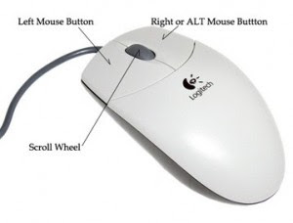

Figure 1.2.2 (b) Mouse

* + **Mouse Actions**
    - Quickly pressing and releasing the mouse button once is called a **click.** For example if we place the cursor over an icon and Click on left mouse button, it will highlight the icon. Clicking on right mouse button will open a shortcut or quick menu.
    - Quickly pressing and releasing the left mouse button twice is called **double click.** This method is used to open a folder or to run a program.
    - To press and continue to hold down the left mouse button and move the mouse is called **dragging**.
    - After dragging releasing the left mouse button to move an object is called **drop**.
  + **Mouse Types**

Some widely used mouse types are as follows:

* **Wheel Mouse –** It contains left and right buttons and a middle scrolling button which is used to move the page up and down means scrolling. The wheel mouse has a ball under it that rotates when a user drags the mouse. In this way screen pointer is controlled.

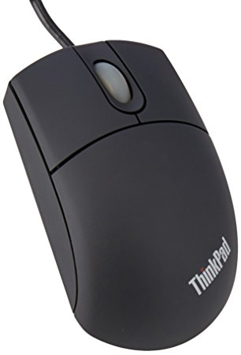

Figure 1.2.2 (c) Wheel Mouse

* **Laser Mouse –** It is similar to the wheel mouse but the difference is that it emits a laser beam of light to get through mouse pad instead of a rolling ball.

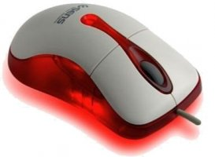

Figure 1.2.2 (d) Laser Mouse

* **Wireless Mouse –** A wireless mouse does not require a cable to attach with the computer. It consists of an internal battery like dry cell, so that it performs all other mouse functions using wireless technology.

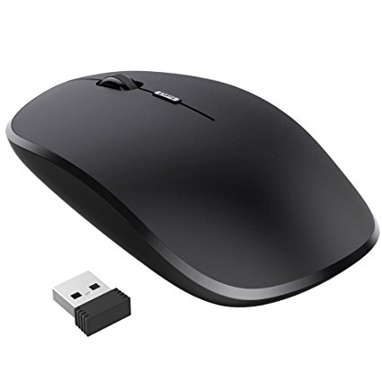

Figure 1.2.2 (e) Wireless Mouse

* **Scanner**

A **scanner** is an input device. It converts hard copy into soft copy. It is used to scan text and images into the computer. So a user can use the scanned document for printing, uploading or to send via mail.

Nowadays latest scanners provide a facility of **OCR** which stands for **Optical Character Recognition**. OCR converts the scanned photo/ image of typewritten or printed text into computer readable format. So a user can edit it in a Word Processor like MS Word.

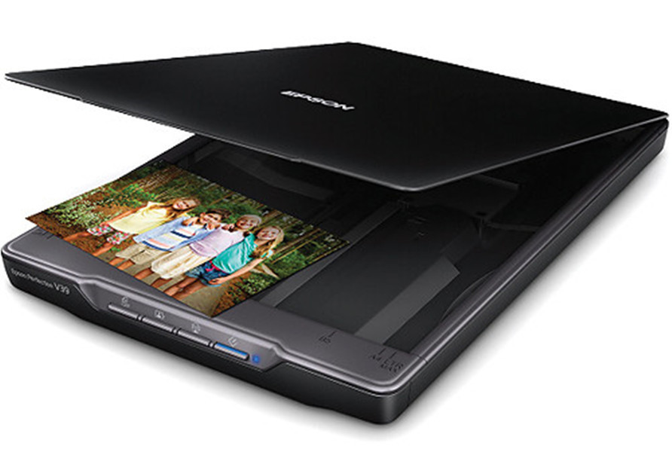

Figure 1.2.2 (f) Scanner

* **Digital Camera**

**Digital camera** is a very popular input device that is used to capture photos. These pictures can be transferred to the computer as it can be connected to a computer through USB very easily. Many cameras provide facility to edit pictures with the help of built-in functions. Pictures taken by the camera are stored in its own memory. So no need it to record them on extra film.

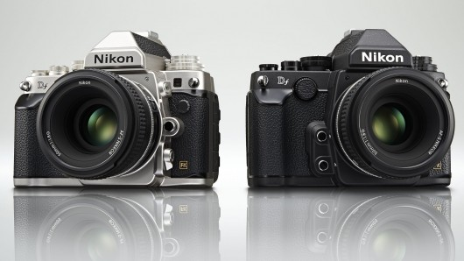

Figure 1.2.2 (g) Digital Camera

DO YOU KNOW?

A digital single-lens reflex camera (DSLR) is a digital camera that combines the optics and the mechanisms of a single-lens reflex camera with a digital imaging sensor, as opposed to photographic film. 

.

* **Microphone**

A **microphone** is an input device used to input audio into the computer. A microphone could be used to input audio for a video, for voice recognition, computer gaming, video calling etc.

The microphone is plugged into the back of [desktop computers](https://www.computerhope.com/jargon/d/desktopc.htm) into the computer [sound card](https://www.computerhope.com/jargon/s/souncard.htm) microphone port. On a [laptop computer](https://www.computerhope.com/jargon/l/laptop.htm), the microphone is plugged into the microphone port found on the front or side of the laptop.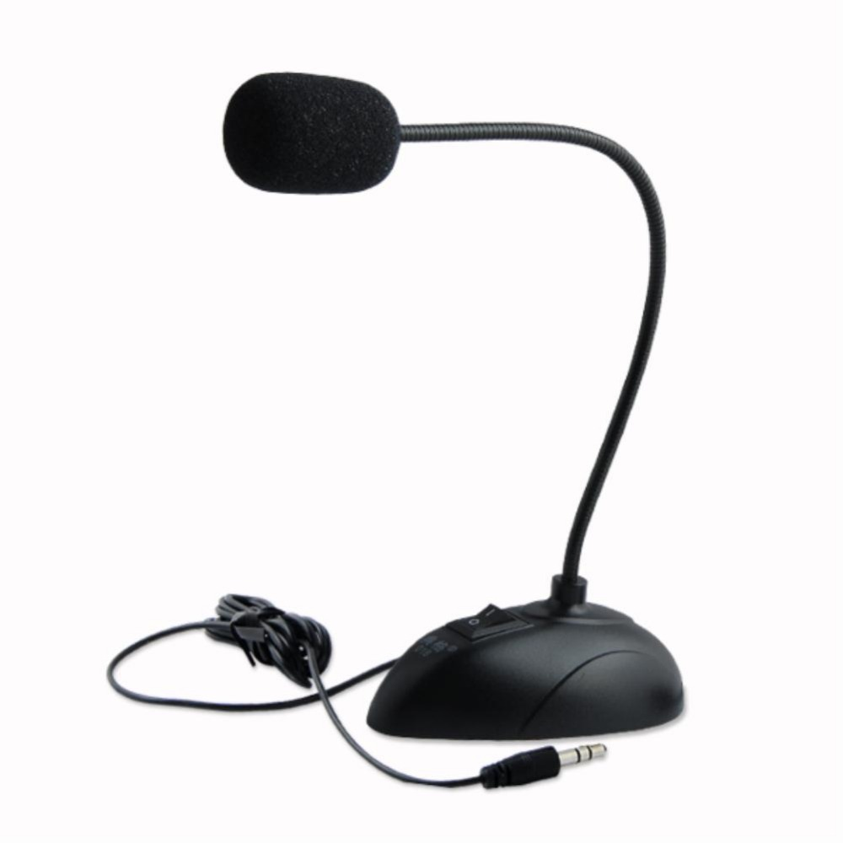

Figure 1.2.2 (h) Microphone

Apart from these devices, webcams, electronic card readers, bar code readers, joysticks, digitizers, light pens etc are also input devices.

# System Unit

The computer **system unit** is the enclosure for all the other main interior components of a computer. It is also called the **computer case**, **computer chassis**, or **computer tower**. These components include hard disk drive, power supply unit, motherboard, optical drive, fan etc.

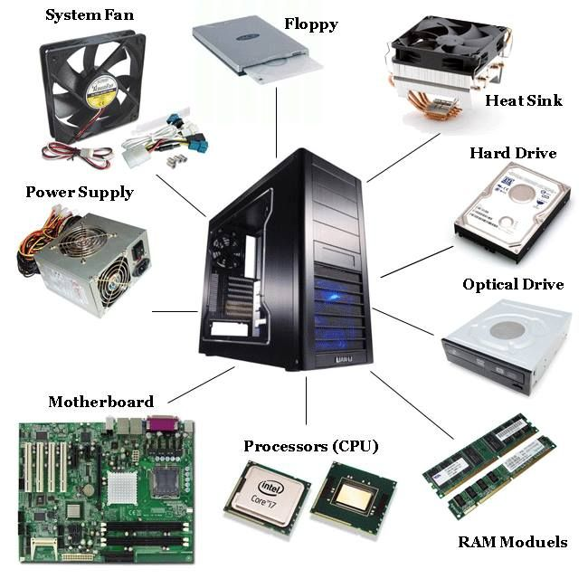

Figure 1.2.3 (a) Components of system unit

* **Processor**

**Processor** is the brain of a computer. It is made of a silicon chip fixed on the motherboard. Its primary job is to carry out a set of instructions and process data efficiently and accurately. It converts data into information. It is also called CPU (CentralProcessing Unit).

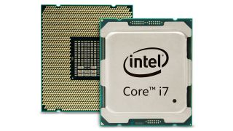

Figure 1.2.3 (b) Core i7 Processor

A **central processing unit (CPU)** is the [electronic circuitry](https://en.wikipedia.org/wiki/Electronic_circuit) within a [computer](https://en.wikipedia.org/wiki/Computer) that carries out the [instructions](https://en.wikipedia.org/wiki/Instruction_(computing)) of a [computer program](https://en.wikipedia.org/wiki/Computer_program) by performing the basic [arithmetic](https://en.wikipedia.org/wiki/Arithmetic), logical, control and [input/output](https://en.wikipedia.org/wiki/Input/output) (I/O) operations specified by the instructions.

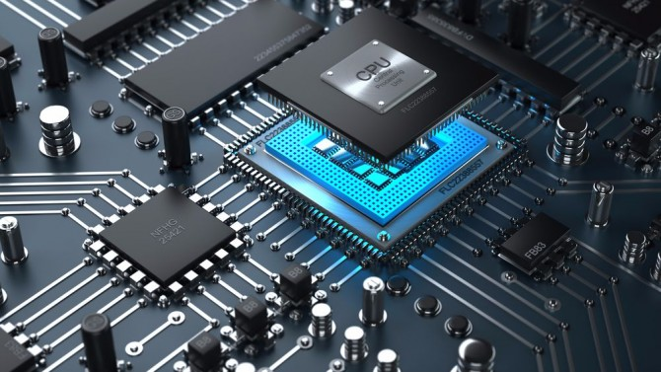

Figure 1.2.3 (c) central processing unit

* **Motherboard**

**Motherboard** is the largest circuit board in computer. It is also known as the **circuit board**. The motherboard is a printed [circuit board](https://www.computerhope.com/jargon/p/pcb.htm) (PCB) that is the foundation of a computer, located on the back side or at the bottom of the computer [chassis](https://www.computerhope.com/jargon/c/chassis.htm). It allocates power and allows communication to the [CPU](https://www.computerhope.com/jargon/c/cpu.htm), [RAM](https://www.computerhope.com/jargon/r/ram.htm), and all other computer [hardware](https://www.computerhope.com/jargon/h/hardware.htm) components. All the components of a computer are connected with the motherboard. Following are some of the components that are attached with the motherboard:

* Processor
* Input/Output devices
* Memory Chips
* Storage Devices
* [Heat sink](https://www.computerhope.com/jargon/h/heatsink.htm)

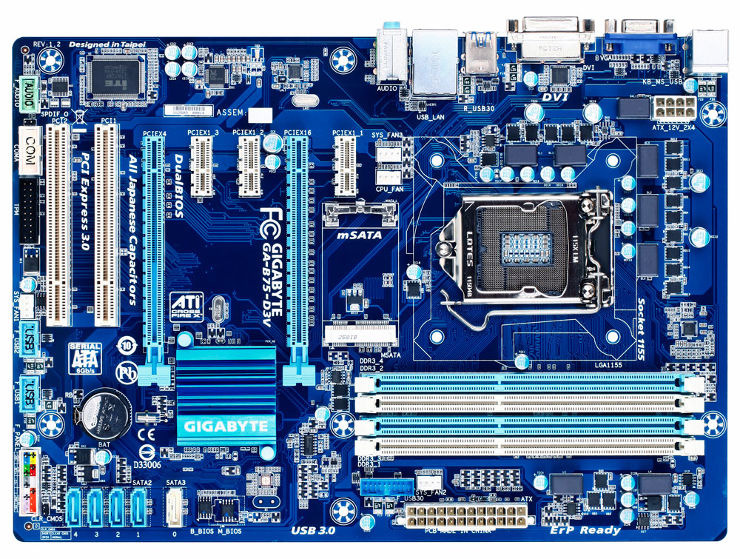

Figure 1.2.3 (d) Motherboard

* **Memory**

Computer **memory** is any physical device capable of storing information temporarily or permanently. Memory can be either [volatile](https://www.computerhope.com/jargon/v/volamemo.htm) or [non-volatile](https://www.computerhope.com/jargon/n/nonvolat.htm). **Volatile memory** is a memory that loses its contents when the computer or hardware device loses power. Computer RAM is an example of a volatile memory. **Non-volatile memory** is a memory that keeps its contents even if the power is lost. [EPROM](https://www.computerhope.com/jargon/e/eprom.htm) is an example of a non-volatile memory. 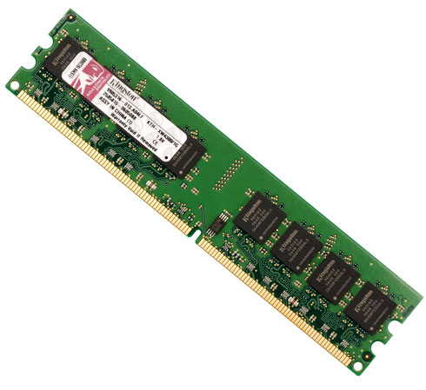

Figure 1.2.3 (e) Computer Memory

Try It Yourself!

**Find out how much RAM is installed and available in**

**Windows 10**

* From the Start screen or Start Menu type ‘ram’
* Windows should return an option for

“View Ram info”. Click on this option. In the

Window that appears you should see how much

installed memory (RAM) your computer has.



DO YOU KNOW?

**Cache memory** is a very high speed semiconductor memory which can speed up the CPU. It acts as a buffer between the CPU and the main memory. It is used to hold those parts of data and program which are most frequently used by the CPU.

.

# Storage Devices

A **storage device** is any [hardware](https://www.computerhope.com/jargon/h/hardware.htm) capable of holding information either temporarily or permanently. There are two types of storage devices used with computers: a [primary storage](https://www.computerhope.com/jargon/p/primstor.htm) device, such as [RAM](https://www.computerhope.com/jargon/r/ram.htm), and a [secondary storage](https://www.computerhope.com/jargon/s/secostor.htm) device, like a floppy disk, [hard disk](https://www.computerhope.com/jargon/h/harddriv.htm), CDs/DVDs and USB flash memory. Secondary storage can be [removable](https://www.computerhope.com/jargon/r/remodisk.htm), [internal](https://www.computerhope.com/jargon/i/internal.htm), or [external](https://www.computerhope.com/jargon/e/external.htm) storage.

* **Floppy Disk**

**Floppy disk** is a portable and inexpensive storage device. It consists of a thin magnetic film. This film is enclosed in a plastic case. A standard floppy disk is 3.5” wide and can store 1.44 MB of data.

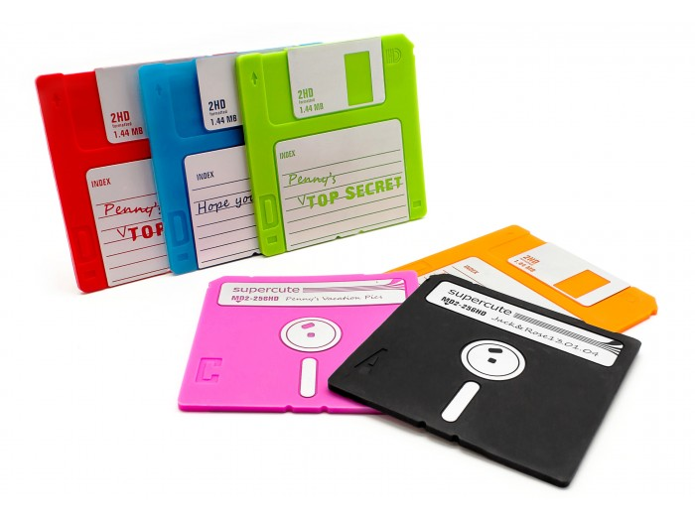

Figure 1.2.4 (a) Floppy disks

Today, due to their extremely limited capacity, computers no longer come equipped with floppy disk drives. This technology has largely been replaced with [CD-R](https://www.computerhope.com/jargon/c/cdr.htm), [DVD-R](https://www.computerhope.com/jargon/d/dvdr.htm), and [flash drives](https://www.computerhope.com/jargon/j/jumpdriv.htm).

* **Hard Disk**

A **hard disk** is a non-volatile computer storage device containing magnetic disks or platters rotating at high speeds. It is a secondary storage device used to store data permanently. A hard disk is also known as a **hard drive** or **hard disk drive (HDD).**

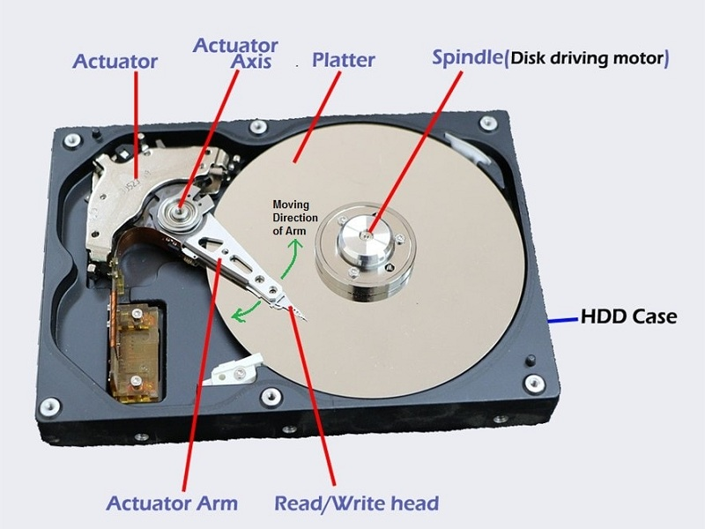

Figure 1.2.4 (b) Hard disk

A hard drive fits inside a computer case and is firmly attached with the use of braces and screws to prevent it from being jarred as the rotating disks or platters spin. The read/write heads of hard disk are controlled by an actuator, which magnetically reads from and writes to the platters.

The hard disk is fixed inside the system storage. All data is stored magnetically, allowing information to be saved when power is shut off. Nowadays, external hard disks are also available in the market.

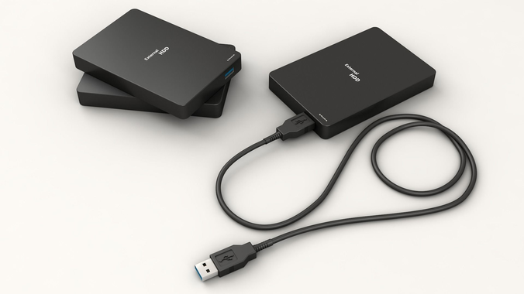

Figure 1.2.4 (c) External hard disk

* **CDs/DVDs**

CD/DVD is a portable and comparatively less reliable storage device than a hard disk. They are flat and round disks made of plastic. A CD/DVD has a thin layer of material that reflects light easily. The CD/DVD drive uses a laser beam to read from and write data on them.

CDs/DVDs are used to store software, data, pictures, movies, music and video games.

|  |  |
| --- | --- |
| **CD** | **DVD** |
| CD stands for Compact Discs | DVD stands for Digital Versatle/Video Disc |
| A CD can run in both CD and DVD drive | A DVD can only run in a DVD drive |
| Quality of sound and video is low | Quality of sound and video is high |
| Maximum storage capacity is 700MB | Maximum storage capacity is 4.7GB single and 9.4GB double sided |

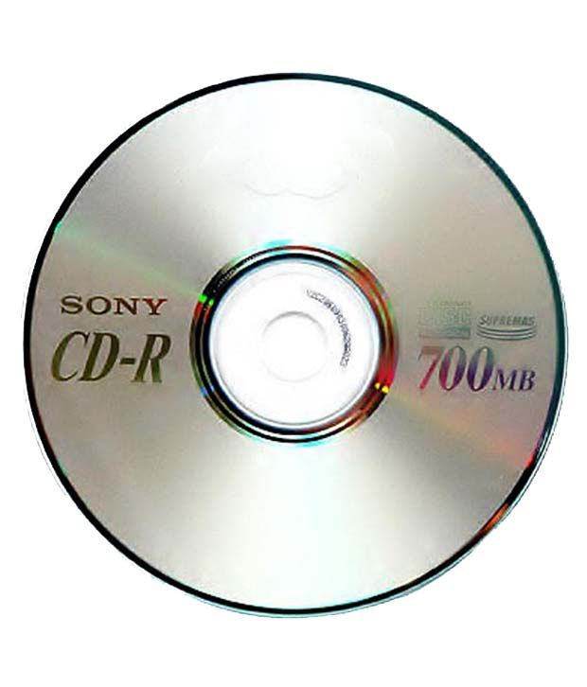

Figure 1.2.4 (d) Compact disk (CD)

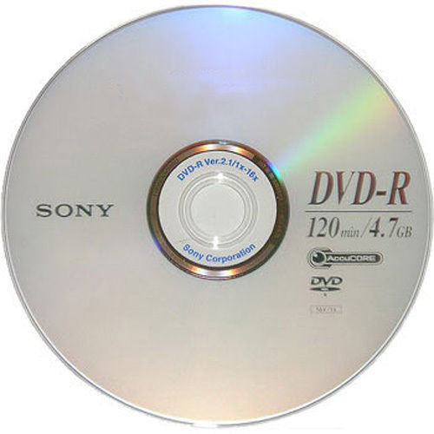

Figure 1.2.4 (e) DVD

* **USB Flash Memory**

A **USB flash memory** or **flash drive** is a small, ultra-portable storage device which, unlike an [optical drive](https://www.lifewire.com/what-is-an-optical-disc-drive-2618157) or a traditional [hard drive](https://www.lifewire.com/what-is-a-hard-disk-drive-2618152), has no moving parts. A USB flash drive is a device used for data storage that includes a flash memory and an integrated Universal Serial Bus (USB) interface.  Most USB flash drives are removable and rewritable. The larger their storage space, the faster they tend to operate. Most flash drives have a storage capacity from 2 GB to 64 GB. Flash drives are often referred to as pen drives, thumb drives, or jump drives. The terms USB drive and solid state drive (SSD) are also sometimes used.

To use a flash drive, just insert the drive into a free USB [port on the computer](https://www.lifewire.com/mac-usb-c-to-old-peripherals-4122273). On most computers, you will be alerted that the flash drive was inserted and the contents of the drive will appear on the screen.

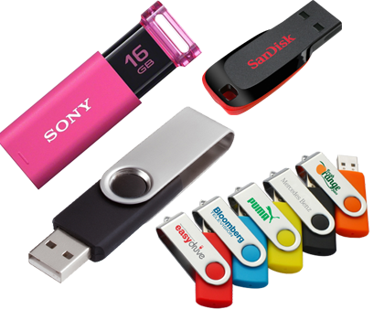

Figure 1.2.4 (f) USB flash memory

DO YOU KNOW?

The world’s highest capacity USB Flash drive, Data Traveler Ultimate GT by Kingston Digital Inc., offers up to 2TB of storage space



.

# Output Devices

Once the data is processed it can be displayed in different ways. Devices that show/generate output are called **output devices.** Monitors, printers and speakers are some examples of output devices.

* **Monitor**

A computer **monitor** is an output device which displays information in pictorial form. A monitor usually comprises of the [display device](https://en.wikipedia.org/wiki/Display_device), [circuitry](https://en.wikipedia.org/wiki/Electronic_circuit), casing, and power supply. Monitor is also known as **Visual Display Unit (VDU).** The output that is displayed on the monitor screen is called soft copy. Following are some of the most common types of available monitor displays.

* + **Cathode Ray Tube (CRT)**

CRT monitors are heavier, need more space and produce small amount of radiation. In this, a stream of intense high energy electrons is used to form images on a fluorescent screen.

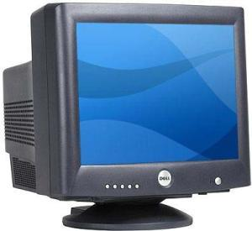

Figure 1.2.5 (a) CRT monitor

* + **LCD**

**LCD** stands for liquid crystal display.  The technology works by passing an electric current through liquid crystal which is contained between two sheets of polarizing material.

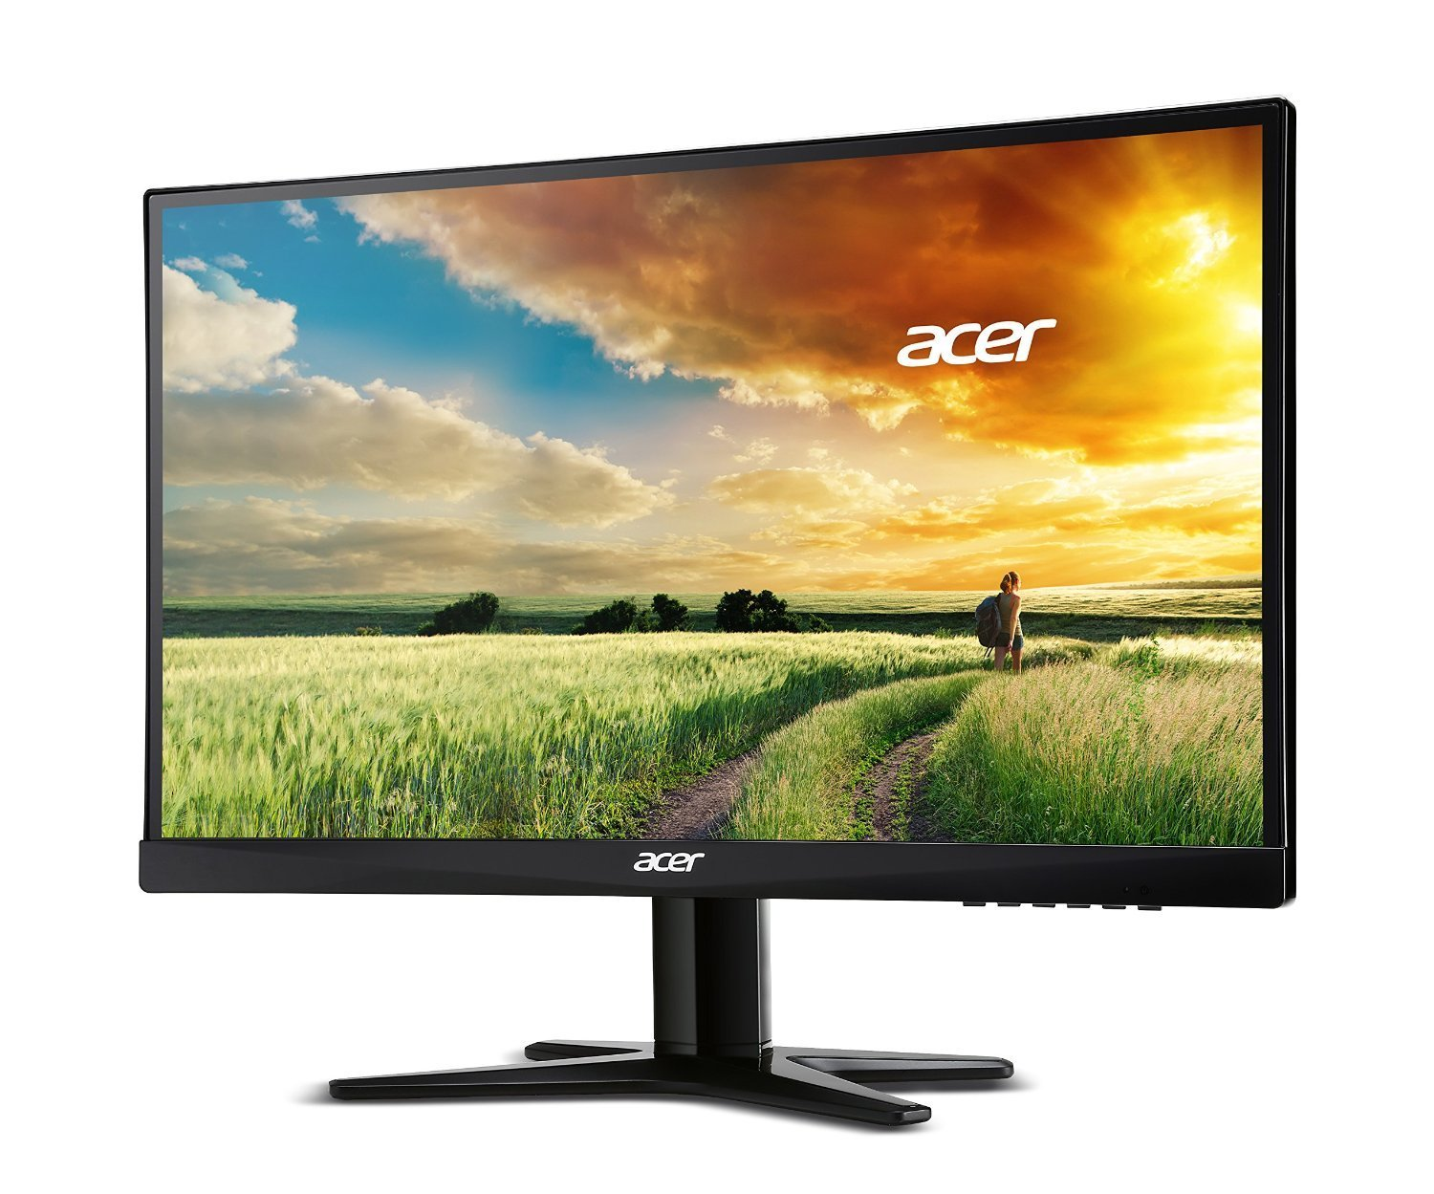

Figure 1.2.5 (b) LCD monitor

* + **LED or OLED**

**Light Emitting Diode (LED)** or **Organic LED** **(OLED)** is a flat panel display making use of light-emitting diodes for back-lightning instead of Cold Cathode Fluorescent (CCFL) back-lightning used in LCDs.

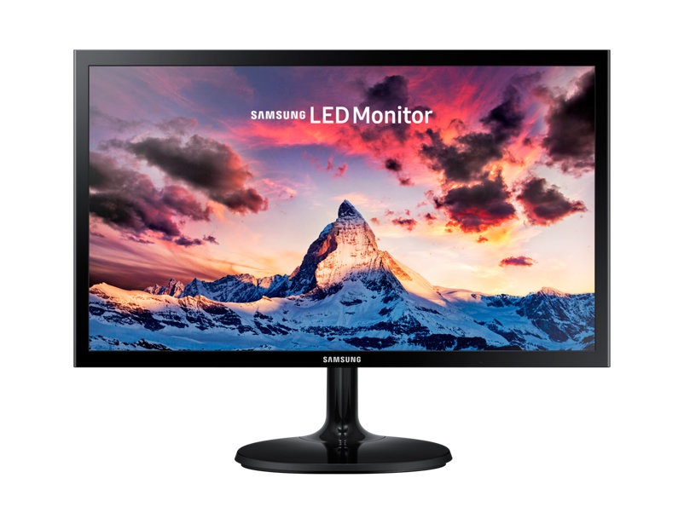

Figure 1.2.5 (c) LED monitor

* + **Plasma Display**

**Plasma Display** is a type of flat panel display that utilizes small cells containing electrically charged ionized gas.

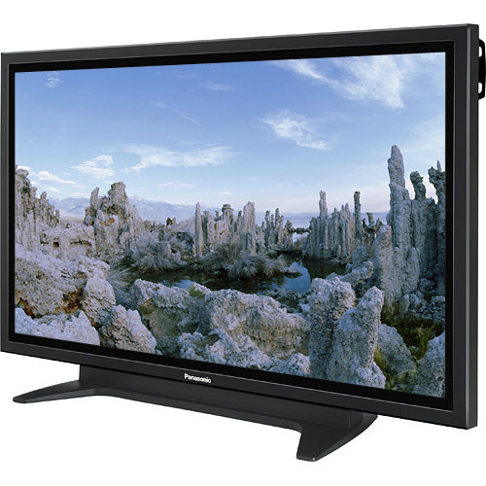

Figure 1.2.5 (d) Plasma Display

* **Printer**

Printer is an output device, which is used to print information on paper. The printed output is called hard copy. There are two types of printers

* + **Impact Printers**

**Impact printers** print the characters by striking them on the ribbon, which is then pressed on the paper. They have very low consumable costs and useful for bulk printing due to low cost. Impact printers are very noisy and there is physical contact with the paper to produce an image. Examples of impact printers are dot matrix printer and daisy wheel printer.

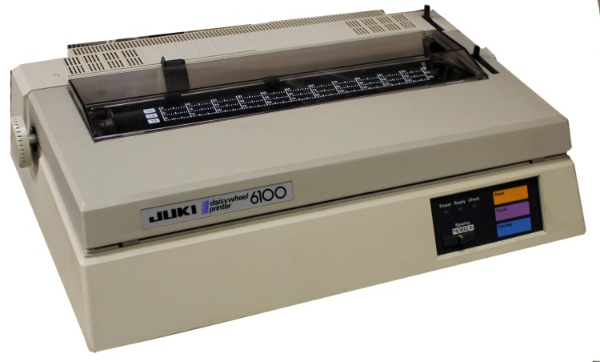

Figure 1.2.5 (e) Daisy wheel printer

* + **Non-Impact Printers**

**Non-impact printers** print the characters without using the ribbon. These printers print a complete page at a time, thus they are also called as **Page Printers.** Examples of non-impact printers are inkjet printers and laser printers.

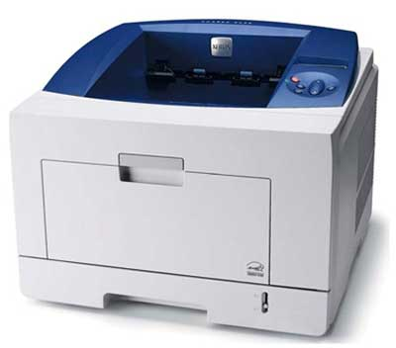

Figure 1.2.5 (f) Laser printer

* **Speakers**

**Speakers** are popular output devices used with computer systems. They receive audio input from the computer's sound card and produce audio output in the form of sound waves. Mostly computers come with in-built speakers but you can also attach external speakers with the sound output jack. These days Bluetooth and wireless speakers are also widely used.

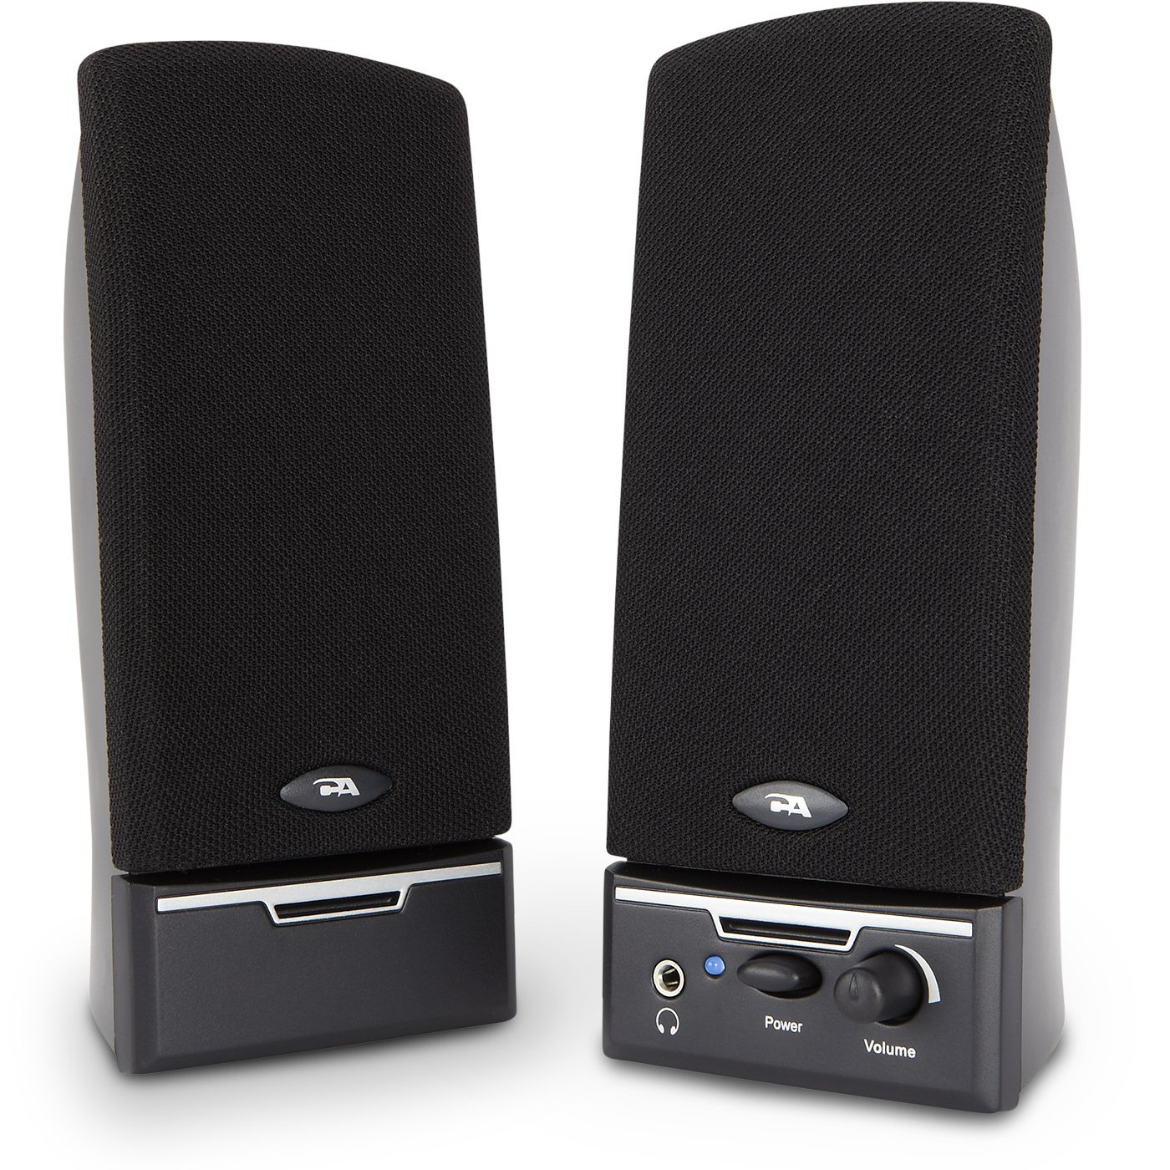

Figure 1.2.5 (g) Speakers

# Communication Devices

The devices which are used to communicate and connect a computer with other computers are known as **communication devices.**

**Modem**

A modem is a device which is used to connect and communicate with other computers on the internet. There are two types of modems, internal and external modem. We will discuss modems in detail in unit 4.

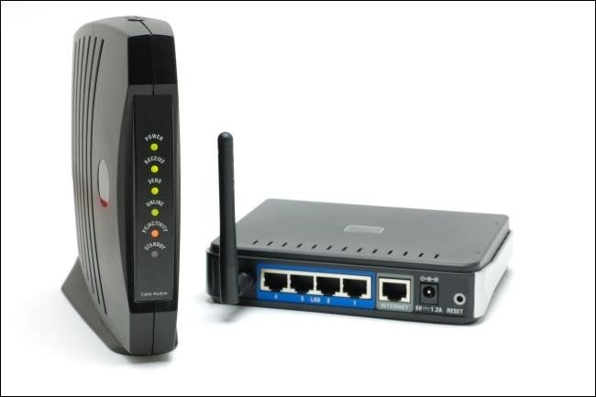

Figure 1.2.6 modem

# How a Computer Works?

The way a computer works is very much similar to the way human beings solve their problems. But computers can solve these problems much faster and with accuracy. The four major operations performed by the computer are input, processing, storage and output.

|  |  |  |
| --- | --- | --- |
|  | **You** | **Computer** |
| Input | You read a question J:\PTBB\unit 1\kids-reading-collection-007.jpg | Computer receives numbers from the keyboard J:\PTBB\unit 1\input-clipart-keyboard.gif |
| Processing | You think about the question and solve it J:\PTBB\unit 1\kids-studying-clipart-12.jpg | Computer processor or CPU works on the numbers. J:\PTBB\unit 1\maxresdefault.jpg |
| Output | You write answer on a paper J:\PTBB\unit 1\kids-doing-homework-collection-006.jpg | Computer shows result on a monitor J:\PTBB\unit 1\22561-hello-computer-screen-clip-art.png |
| Storage | You can save your work in your bag to use it later J:\PTBB\unit 1\download.jpg | Computer can use disks, CDs, DVDs to store data J:\PTBB\unit 1\cds-and-dvds.png |

* **Input Operation**

In this operation, the computer accepts data and instructions from input devices. The input devices include keyboard, mouse scanner, digital camera, microphone etc.

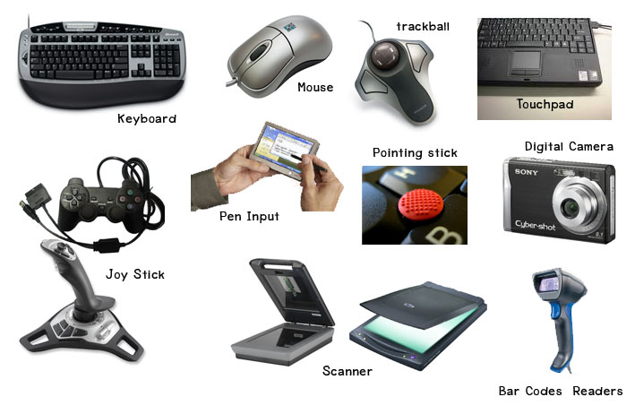

Figure 1.3 (a) Input devices

* **Processing Operation**

The operation in which a computer performs some action on the data according to the instructions is known as **processing operation**. The processing is done by the Central Processing Unit (CPU).

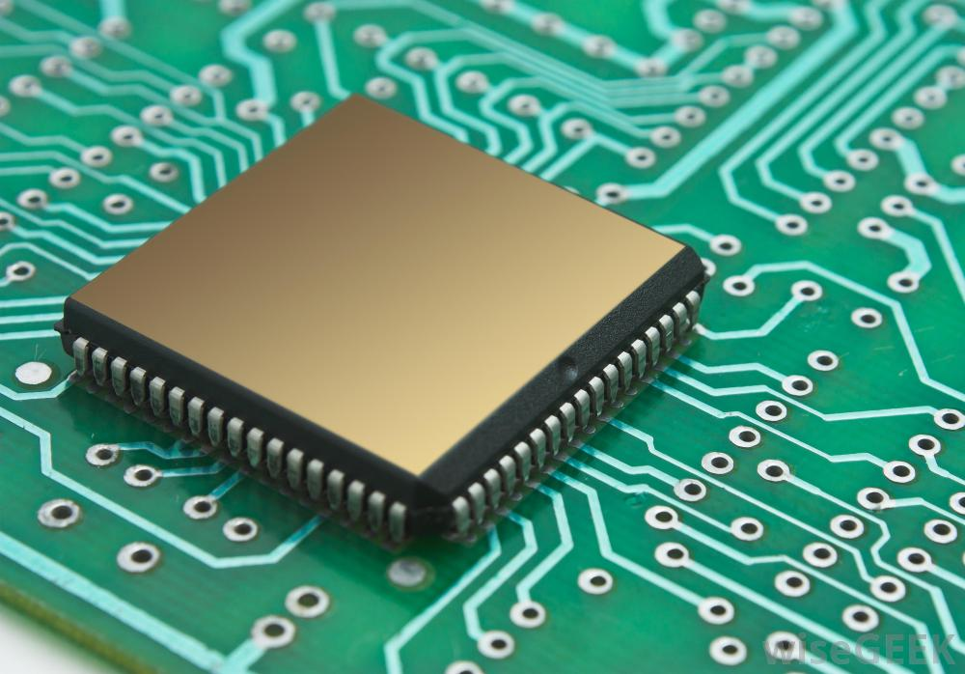

Figure 1.3 (b) Processor

* **Output Operation**

In this operation computer uses the output devices to produce results of the processing (information). It may be either displayed on the screen or printed on the paper. Audio output is produced by the speakers of computer.

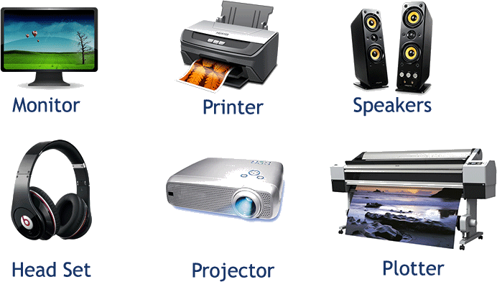

Figure 1.3 (c) Output devices

* **Storage Operation**

In this operation, the computer stores the data or information on different storage devices such as hard disk, floppy disk, CD/DVD and flash memory.

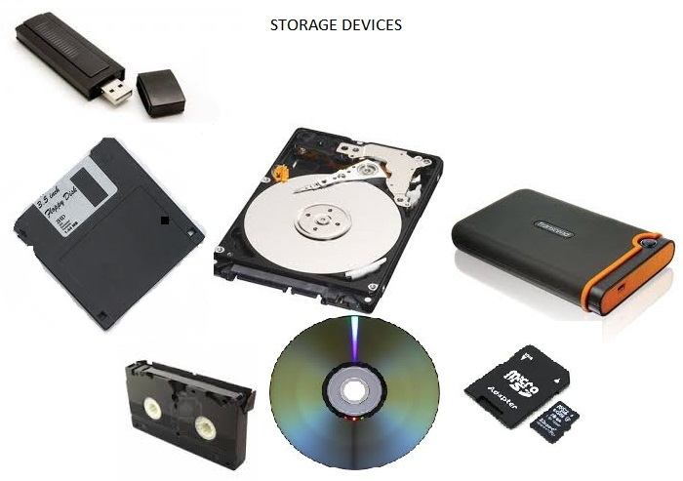

Figure 1.3 (d) Storage devices

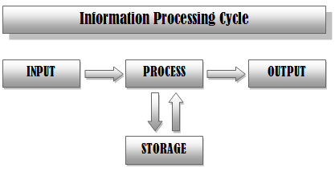

Figure 1.3 (e) How a computer works

User can choose to perform some processing on the input and then store it or to show it on an output device.

SUMMARY

* + A **computer** is an electronic device that manipulates information, or data. It has the ability to store, retrieve, and process data.
  + Desktop computers are designed to be placed on a desk, and they're typically made up of a few different parts, including the computer case, monitor, keyboard, and mouse.
  + **Laptops** are battery-powered computers that are more portable than desktops.
  + **Tablets** are handheld computers that are even more portable than laptops. Tablets use a touch-sensitive screen for typing and navigation.
  + A **server** is a computer that serves up information to other computers on a network.
  + **Data** is the raw material that can be processed by any computing machine. Data can be represented in the form of numbers and words which can be stored in computer's language.
  + When data are processed, organized, structured or presented in a given context so as to make them useful, they are called **Information.**
  + Speed, accuracy, storage, reliability, automation, online shopping, education and weather forecast are some of the advantages of using a computer.
  + **Hardware** is any part of computer that has a physical structure. It includes all those parts that we can see and touch like input unit, output unit and system unit.
  + **Software** is any set of instructions that tells the hardware what to do and how to do it.
  + **Keyboard** allows a user to enter alphabets, numbers or symbols into the computer.
  + **Mouse** is used frequently to control cursor around the screen.
  + A **scanner** is an input device. It converts hard copy into soft copy. It is used to scan text and images into the computer.
  + **Digital camera** is an input device that is used to capture photos. These pictures can be transferred to the computer as it can be connected to a computer through USB very easily.
  + A **microphone** is an input device used to input audio into the computer.
  + The computer **system unit** is the enclosure for all the other main interior components of a computer. It is also called the **computer case**, **computer chassis**, or **computer tower**.
  + **Processor** is the brain of a computer. Its primary job is to carry out a set of instructions and process data efficiently and accurately. It is also called CPU (Central Processing Unit).
  + **Motherboard** is the largest circuit board in computer. All the components of a computer are connected with the motherboard.
  + Computer **memory** is any physical device capable of storing information temporarily or permanently.
  + **Volatile memory** is a memory that loses its contents when the computer or hardware device loses power.
  + **Non-volatile memory** is a memory that keeps its contents even if the power is lost.
  + A **storage device** is any hardware capable of holding information either temporarily or permanently.
  + **Floppy disk** is a portable and inexpensive storage device. It consists of a thin magnetic film. This film is enclosed in a plastic case.
  + A **hard disk** is a non-volatile computer storage device containing magnetic disks or platters rotating at high speeds. It is a secondary storage device used to store data permanently. A hard disk is also known as a **hard drive** or **hard disk drive (HDD).**
  + **CD/DVD** is a portable and comparatively less reliable storage device than a hard disk. They are flat and round disks made of plastic.
  + A **USB flash memory** or **flash drive** is a small, ultra-portable storage device which, unlike an optical drive or a traditional hard drive, has no moving parts.
  + Once the data is processed it can be displayed in different ways. Devices that show/generate output are called **output devices.**
  + A computer **monitor** is an output device which displays information in pictorial form.
  + **Printer** is an output device, which is used to print information on paper. The printed output is called hard copy.
  + **Speakers** are popular output devices used with computer systems. They receive audio input from the computer's sound card and produce audio output in the form of sound waves.
  + The devices which are used to communicate and connect a computer with other computers are known as **communication devices.**
  + A **modem** is a device which is used to connect and communicate with other computers on the internet.
  + The way a computer works is very much similar to the way human beings solve their problems. But computers can solve these problems much faster and with accuracy.
  + In **input operation**, the computer accepts data and instructions from input devices.
  + The operation in which a computer performs some action on the data according to the instructions is known as **processing operation**.
  + In **output operation** computer uses the output devices to produce results of the processing (information).
  + In **storage operation**, the computer stores the data or information on different storage devices.

EXERCISE

**Q.1 Tick the right choice**

1) A ____________ is an electronic device that manipulates information or data

a)printer b)computer c)monitor d)calculator

2) **_______** are plain facts.

a) information b) news c)data d)knowledge

3) ______________includes all those parts that we can see and touch

a) hardware b)software c)computer d)motherboard

4) Which of the following is an example of a software?

a) monitor b)keyboard c)web browser d) mouse

5)In the standard keyboard, keys are laid in __________ pattern.

a) QUARTX b)QWERT c) QWERTY d)QUERTY

1. The purpose of _________ keys is based on the software we are using.
2. Numeric keys b) alphanumeric keys c) function keys d)navigation keys
3. Quickly pressing and releasing the mouse button once is called a **_________**
4. Click b) double click c)drag d)drop
5. OCR stands for _______________________
6. Optical Cursor Recognition b)Optical Character Recognition c) Overall Character Recognition  **d)**Only Character Recognition
7. A **__________** is an input device used to input audio into the computer
8. Speakers b) microphone c) scanner d) keyboard
9. Which of these is not placed inside system unit?
10. Motherboard b)hard disk c)RAM d)printer
11. __________ is the brain of computer
12. Monitor b) keyboard c)processor d) motherboard
13. All the components of a computer are connected with the ______________
14. Motherboard b)processor c)monitor d)keyboard
15. RAM is an example of a ________ memory
16. Non-volatile b)volatile c)cache d)buffer
17. A standard floppy disk is 3.5” wide and can store _____ MB of data.
18. 1.44 b)1.55 c)1.66 d)1.77
19. There are ___________ basic operations performed by the computer
20. Three b)four c)five d)six

**Q.2 Fill in the blanks**

**1) _________** are battery-powered computers that are more portable than desktops.

2) When data are processed, organized, structured or presented in a given context so as to make them useful, they are called **___________**

**3) ___________** means ability to perform the given task automatically.

4) _________ is developed by writing instructions in programming language.

5) The collection of letters, numbers and punctuation keys along with some special keys is known as _________________

6) A __________ mouse does not require a cable to attach with the computer.

7) ______________ is the enclosure for all the other main interior components of a computer.

8) _________ monitors are heavier, need more space and produce small amount of radiation.

9) A **____________** is a non-volatile computer storage device containing magnetic disks or platters rotating at high speeds.

10) _________ printersprint the characters by striking them on the ribbon, which is then pressed on the paper.

**Q.3 Define the following**

1) Computer 2) information 3)hardware 4)system unit 5)motherboard 6)memory 7)hard disk 8)processing operation

**Q.4 Differentiate between the following**

1) Data and information 2)volatile and non-volatile memory 3) hardware and software 4) CD and DVD 5)human and computer

6) input and output operation

**Q.5 Give brief answers to the following questions**

1) What are the types of computers?

2) What are the advantages of using a computer?

3) What is a keyboard and classification of its keys?

4) What are the four main mouse actions?

5) Write a short note on central processing unit.

6) Define computer memory and its types.

7) Define printer and its types.

8) Define four major operations performed by a computer.

9) What is a monitor? Explain any three types of monitors.

10) Write a short note on motherboard.

**Q.6 Match column A with column B and write the numbers of matching pairs in column C.**

|  |  |  |
| --- | --- | --- |
| **A** | **B** | **C** |
| 1)software | a)timely | 1d |
| 2)Tablet | b)Joy stick |  |
| 3)information | c)EPROM |  |
| 4)alphanumeric keys | d)MS Word |  |
| 5)input device | e)PCB |  |
| 6)system unit | f)Visual Display Unit |  |
| 7)motherboard | g)iPad |  |
| 8)non-volatile memory | h)Computer tower |  |
| 9)hard disk | i)Backspace |  |
| 10)Monitor | j)actuators |  |

**Q.7 Label the missing keys in the following diagram**

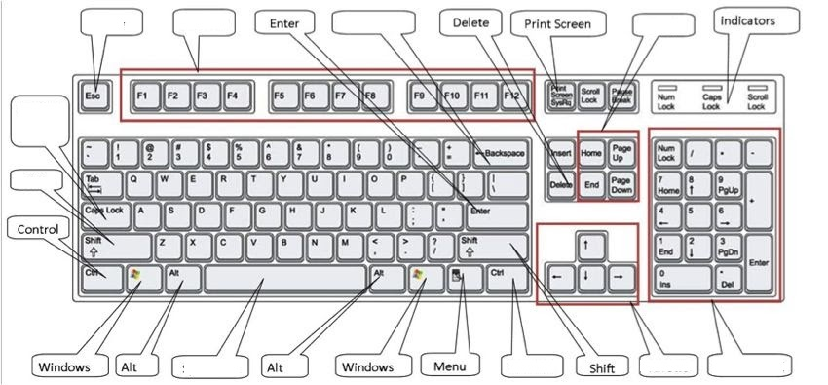

**Q.8 Label the following diagram**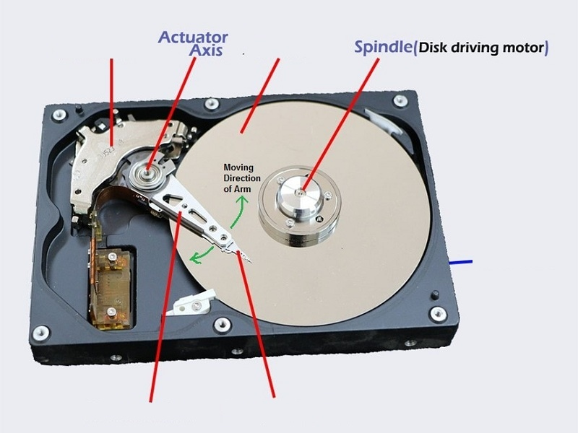

**Lab Activity 1**

350 x 12 = ?

**Part 1**

1. Take a paper and pencil and try to solve this equation.
2. Note down the total time you take to solve it on paper.

**Part 2**

**Step 1:** Bring up Windows 10 start menu and then check if the Calculator utility is displayed in the **Most used** apps list. If yes, click to open it. If not, see the step 2.

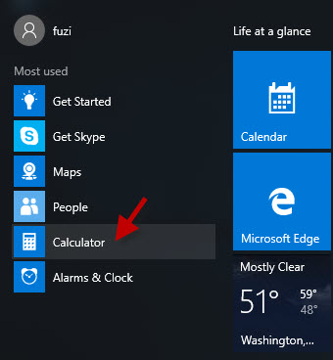

**Step 2:** Type **calc** in the search box of Windows 10 Start menu. Then in the program list, it will display the Calculator app. Click to open it.

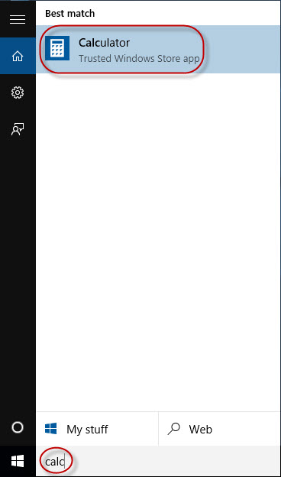

**Step 3:** Now perform the above calculation in the calculator app. Note down time taken to perform the calculation.

**Which way gives faster and more accurate results?**

**Lab Activity 2**

**a)** Write down four hardware devices that you see in your computer lab.

**1) _______________ 2) ________________**

**3) _______________ 4) ________________**

**b)** What type of mouse are you using?

**c)** What type of monitor are you using?

**Lab Activity 3**

Write down names and functions of five softwares installed on your computer.

**Software Function**

1. **_____________ ______________**
2. **_____________ ______________**
3. **_____________ ______________**
4. **_____________ ______________**
5. **_____________ ______________**

**Lab Activity 4**

Scan the following objects and set it as wallpaper for your computer screen. Get the help of your teacher for this activity.



**Lab Activity 5**

1. With the help of your teacher, print out a picture of your favorite cartoon character.
2. What type of printer are you using?

**Lab Activity 6**

Discuss with your teacher about the following qualities of storage devices. Choose one of the following options.

**YES NOT MUCH NO**

|  |  |  |  |  |  |
| --- | --- | --- | --- | --- | --- |
| **Attributes** | **Floppy disk** | **Hard disk** | **CD** | **DVD** | **Flash Memory** |
| **Expensive** |  |  |  |  |  |
| **Portable** |  |  |  |  |  |
| **Reliable** |  |  |  |  |  |
| **Durable** |  |  |  |  |  |
| **High storage Capacity** |  |  |  |  |  |